**EX NO :13 BPO MANAGEMENT SYSTEM**

USE CASE DIAGRAM :

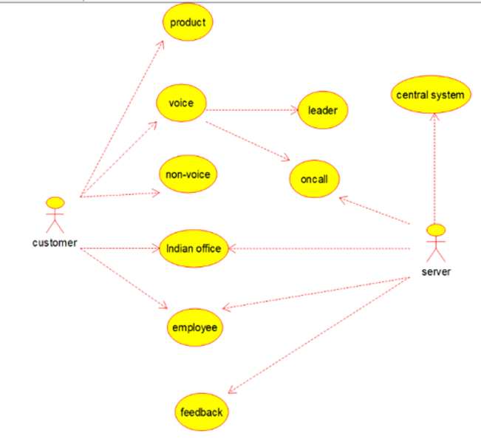

CLASS DIAGRAM: 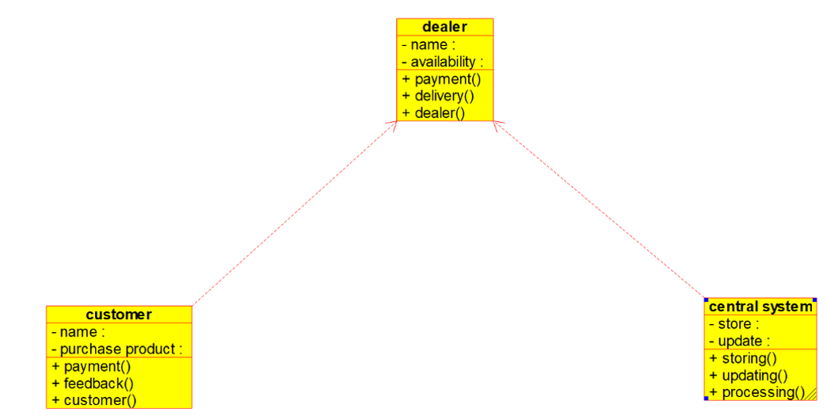

ACTIVITY DIAGRAM:

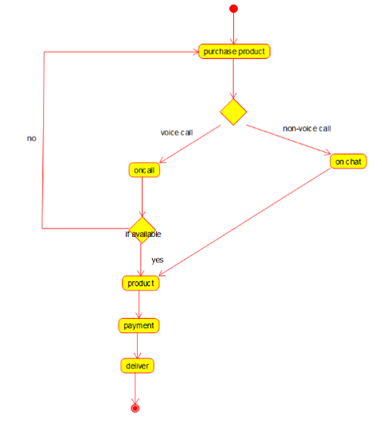

SEQUENCE DIAGRAM:

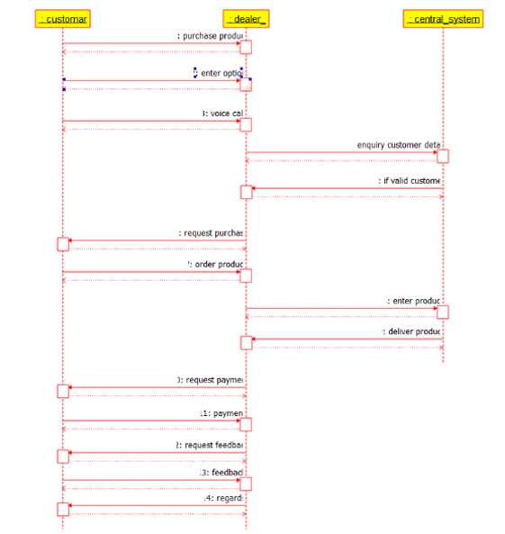

COLLABRATION DIAGRAM: 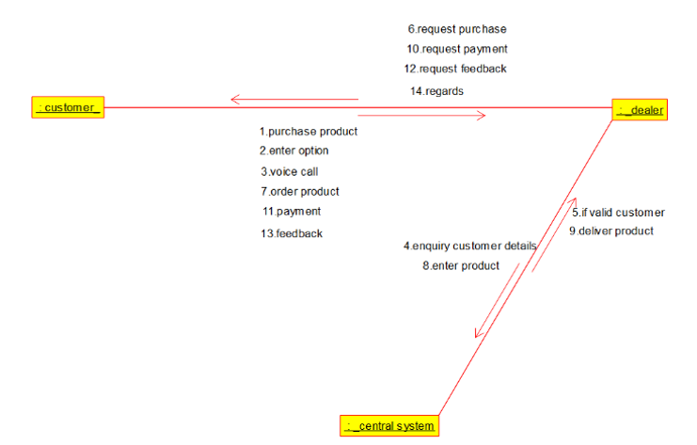

STATE CHART DIAGRAM:

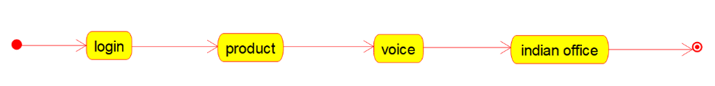

COMPONENT DIAGRAM:

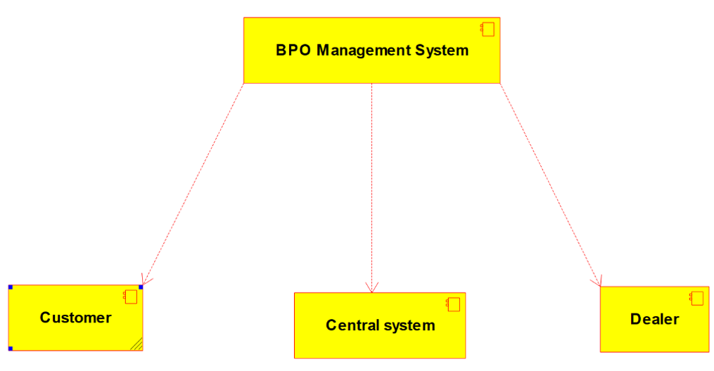

DEPLOYMENT DIAGRAM:

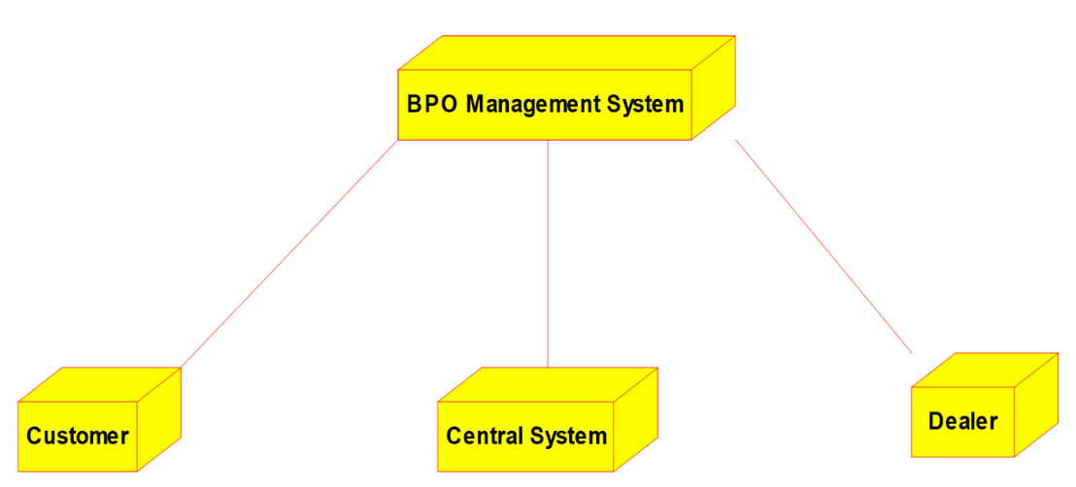

PROGRAM:

**CENTRAL SYSTEM*:***

/**

* Class central_system

*/

public class central_system {

//

// Fields

//

private void store;

private void update;

//

// Constructors

//

public central_system () { };

//

// Methods

//

**EXP 13: BPO MANAGEMENT SYSTEM**

USECASE DIAGRAM:

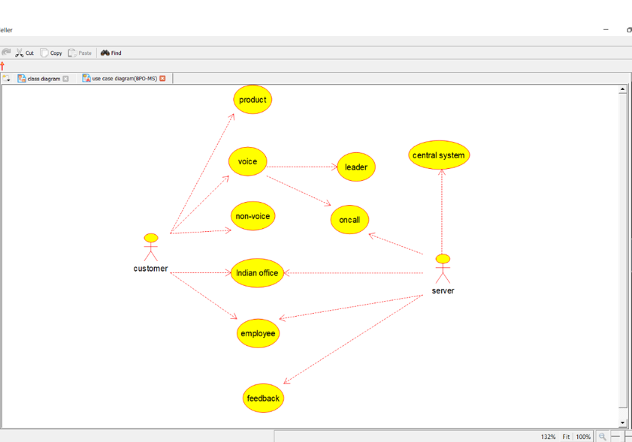

**CLASS DIAGRAM:**

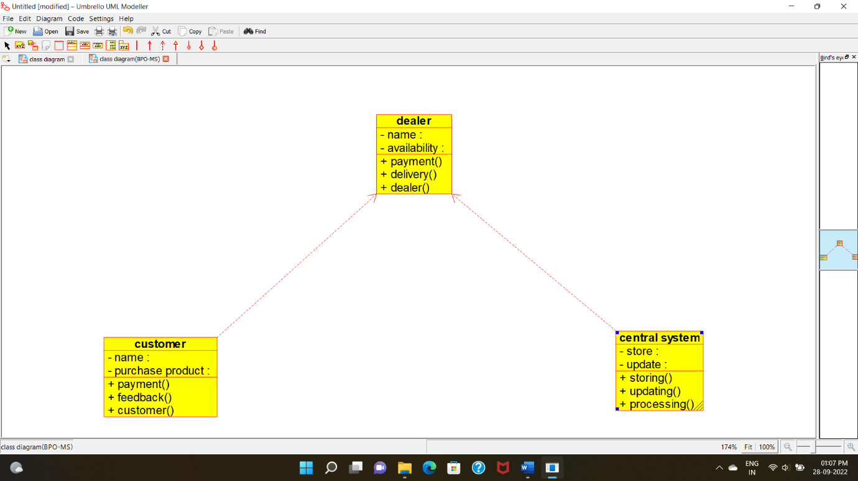

**ACTIVITY DIAGRAM:**

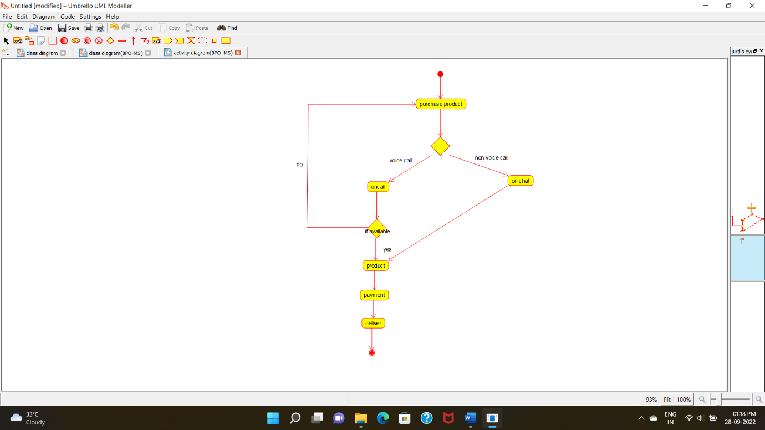

**SEQUENCE DIAGRAM**:

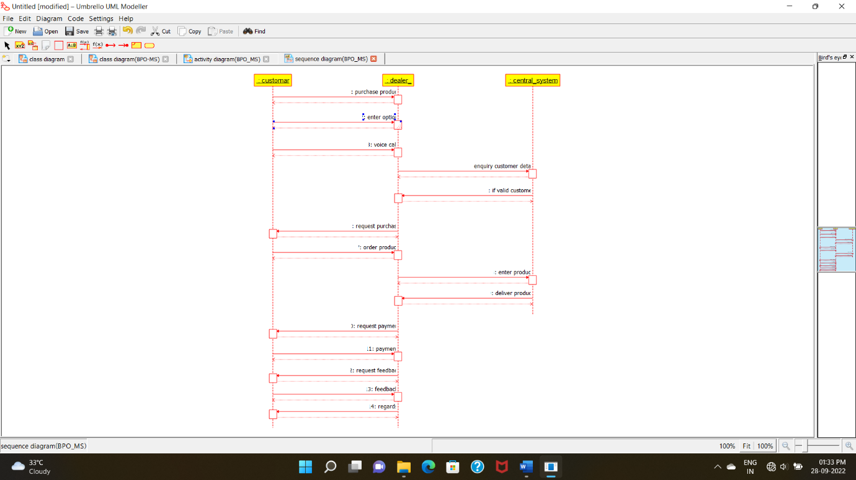

**COLLABORATION DIAGRAM:**

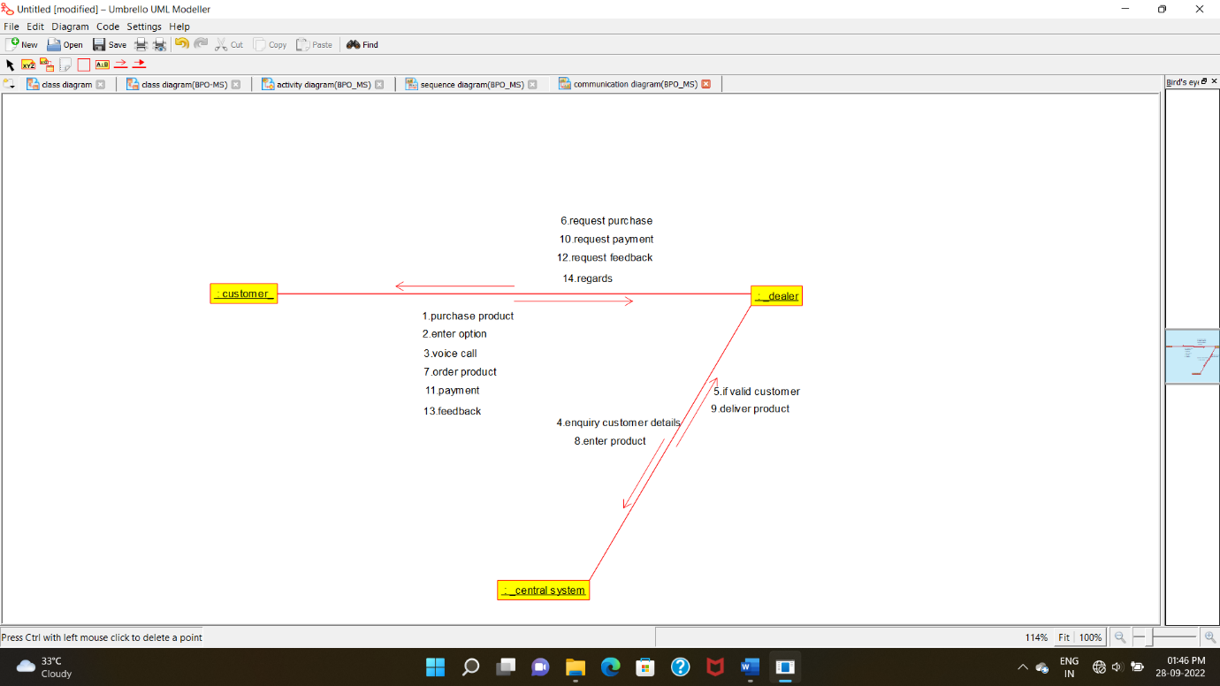

**STATECHART DIAGRAM**:

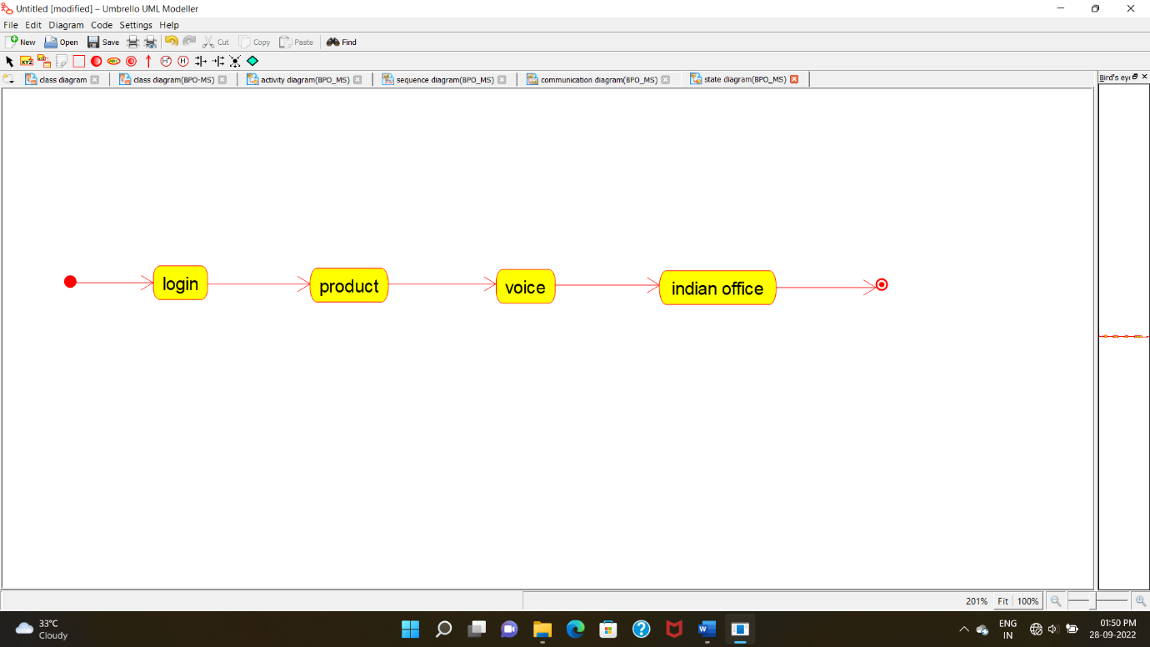

**COMPONENT DIAGRAM:**

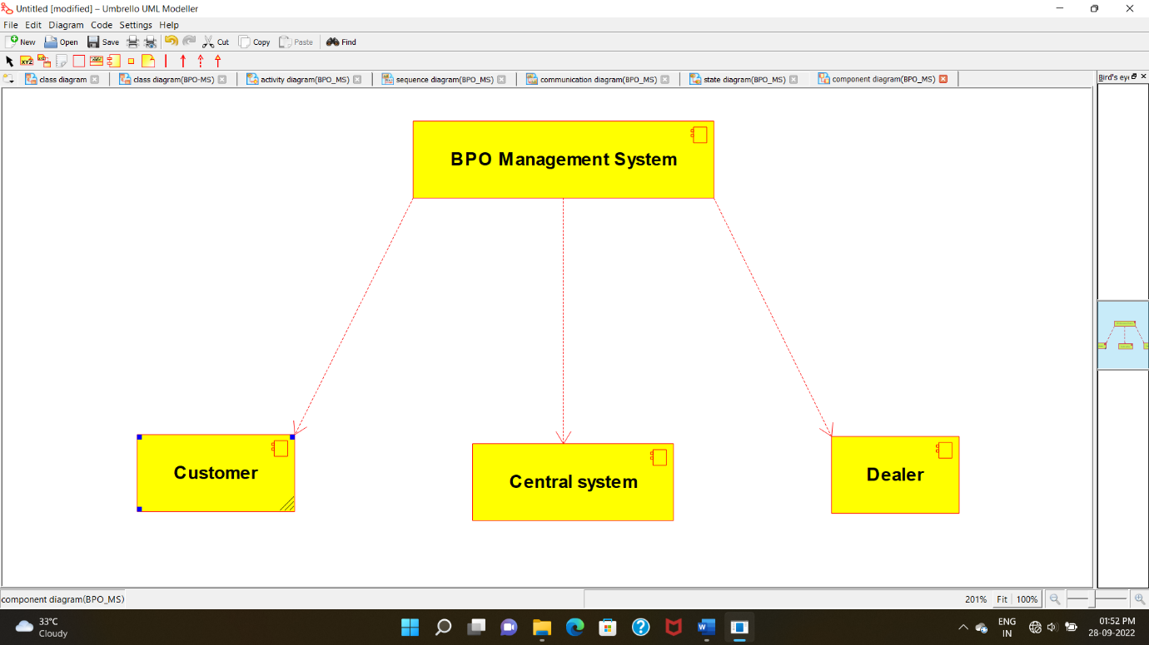

**DEPLOYMENT DIAGRAM**:

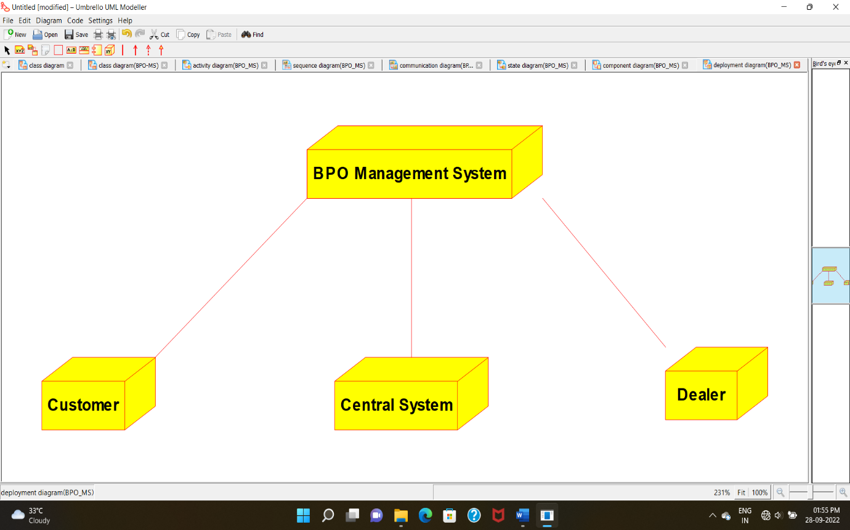

**PROGRAM CODING:**

**CENTRAL SYSTEM*:***

/**

* Class central_system

*/

public class central_system {

//

// Fields

//

private void store;

private void update;

//

// Constructors

//

public central_system () { };

//

// Methods

//

//

// Accessor methods

//

/**

* Set the value of store

* @param newVar the new value of store

*/

private void setStore (void newVar) {

store = newVar;

}

/**

* Get the value of store

* @return the value of store

*/

private void getStore () {

return store;

}

/**

* Set the value of update

* @param newVar the new value of update

*/

private void setUpdate (void newVar) {

update = newVar;

}

/**

* Get the value of update

* @return the value of update

*/

private void getUpdate () {

return update;

}

//

// Other methods

//

/**

*/

public void storing()

{

}

/**

*/

public void updating()

{

}

/**

*/

public void processing()

{

}

}

**CUSTOMER:**

/**

* Class customer

*/

public class customer {

//

// Fields

//

private void name;

private void purchase_product;

//

// Constructors

//

public customer () { };

//

// Methods

//

//

// Accessor methods

//

/**

* Set the value of name

* @param newVar the new value of name

*/

private void setName (void newVar) {

name = newVar;

}

/**

* Get the value of name

* @return the value of name

*/

private void getName () {

return name;

}

/**

* Set the value of purchase_product

* @param newVar the new value of purchase_product

*/

private void setPurchase_product (void newVar) {

purchase_product = newVar;

}

/**

* Get the value of purchase_product

* @return the value of purchase_product

*/

private void getPurchase_product () {

return purchase_product;

}

//

// Other methods

//

/**

*/

public void payment()

{

}

/**

*/

public void feedback()

{

}

/**

*/

public void customer()

{

}

}

**DEALER:**

/**

* Class dealer

*/

public class dealer {

//

// Fields

//

private void name;

private void availability;

//

// Constructors

//

public dealer () { };

//

// Methods

//

//

// Accessor methods

//

/**

* Set the value of name

* @param newVar the new value of name

*/

private void setName (void newVar) {

name = newVar;

}

/**

* Get the value of name

* @return the value of name

*/

private void getName () {

return name;

}

/**

* Set the value of availability

* @param newVar the new value of availability

*/

private void setAvailability (void newVar) {

availability = newVar;

}

/**

* Get the value of availability

* @return the value of availability

*/

private void getAvailability () {

return availability;

}

//

// Other methods

//

/**

*/

public void payment()

{

}

/**

*/

public void delivery()

{

}

/**

*/

public void dealer()

{

}

}

**EXP 13: BPO MANAGEMENT SYSTEM**

USECASE DIAGRAM:



**CLASS DIAGRAM:**



**ACTIVITY DIAGRAM:**



**SEQUENCE DIAGRAM**:



**COLLABORATION DIAGRAM:**



**STATECHART DIAGRAM**:



**COMPONENT DIAGRAM:**



**DEPLOYMENT DIAGRAM**:



**PROGRAM CODING:**

**CENTRAL SYSTEM*:***

/**

* Class central_system

*/

public class central_system {

//

// Fields

//

private void store;

private void update;

//

// Constructors

//

public central_system () { };

//

// Methods

//

//

// Accessor methods

//

/**

* Set the value of store

* @param newVar the new value of store

*/

private void setStore (void newVar) {

store = newVar;

}

/**

* Get the value of store

* @return the value of store

*/

private void getStore () {

return store;

}

/**

* Set the value of update

* @param newVar the new value of update

*/

private void setUpdate (void newVar) {

update = newVar;

}

/**

* Get the value of update

* @return the value of update

*/

private void getUpdate () {

return update;

}

//

// Other methods

//

/**

*/

public void storing()

{

}

/**

*/

public void updating()

{

}

/**

*/

public void processing()

{

}

}

**CUSTOMER:**

/**

* Class customer

*/

public class customer {

//

// Fields

//

private void name;

private void purchase_product;

//

// Constructors

//

public customer () { };

//

// Methods

//

//

// Accessor methods

//

/**

* Set the value of name

* @param newVar the new value of name

*/

private void setName (void newVar) {

name = newVar;

}

/**

* Get the value of name

* @return the value of name

*/

private void getName () {

return name;

}

/**

* Set the value of purchase_product

* @param newVar the new value of purchase_product

*/

private void setPurchase_product (void newVar) {

purchase_product = newVar;

}

/**

* Get the value of purchase_product

* @return the value of purchase_product

*/

private void getPurchase_product () {

return purchase_product;

}

//

// Other methods

//

/**

*/

public void payment()

{

}

/**

*/

public void feedback()

{

}

/**

*/

public void customer()

{

}

}

**DEALER:**

/**

* Class dealer

*/

public class dealer {

//

// Fields

//

private void name;

private void availability;

//

// Constructors

//

public dealer () { };

//

// Methods

//

//

// Accessor methods

//

/**

* Set the value of name

* @param newVar the new value of name

*/

private void setName (void newVar) {

name = newVar;

}

/**

* Get the value of name

* @return the value of name

*/

private void getName () {

return name;

}

/**

* Set the value of availability

* @param newVar the new value of availability

*/

private void setAvailability (void newVar) {

availability = newVar;

}

/**

* Get the value of availability

* @return the value of availability

*/

private void getAvailability () {

return availability;

}

//

// Other methods

//

/**

*/

public void payment()

{

}

/**

*/

public void delivery()

{

}

/**

*/

public void dealer()

{

}

}

**EXP 13: BPO MANAGEMENT SYSTEM**

USECASE DIAGRAM:



**CLASS DIAGRAM:**



**ACTIVITY DIAGRAM:**



**SEQUENCE DIAGRAM**:



**COLLABORATION DIAGRAM:**



**STATECHART DIAGRAM**:



**COMPONENT DIAGRAM:**



**DEPLOYMENT DIAGRAM**:



**PROGRAM CODING:**

**CENTRAL SYSTEM*:***

/**

* Class central_system

*/

public class central_system {

//

// Fields

//

private void store;

private void update;

//

// Constructors

//

public central_system () { };

//

// Methods

//

//

// Accessor methods

//

/**

* Set the value of store

* @param newVar the new value of store

*/

private void setStore (void newVar) {

store = newVar;

}

/**

* Get the value of store

* @return the value of store

*/

private void getStore () {

return store;

}

/**

* Set the value of update

* @param newVar the new value of update

*/

private void setUpdate (void newVar) {

update = newVar;

}

/**

* Get the value of update

* @return the value of update

*/

private void getUpdate () {

return update;

}

//

// Other methods

//

/**

*/

public void storing()

{

}

/**

*/

public void updating()

{

}

/**

*/

public void processing()

{

}

}

**CUSTOMER:**

/**

* Class customer

*/

public class customer {

//

// Fields

//

private void name;

private void purchase_product;

//

// Constructors

//

public customer () { };

//

// Methods

//

//

// Accessor methods

//

/**

* Set the value of name

* @param newVar the new value of name

*/

private void setName (void newVar) {

name = newVar;

}

/**

* Get the value of name

* @return the value of name

*/

private void getName () {

return name;

}

/**

* Set the value of purchase_product

* @param newVar the new value of purchase_product

*/

private void setPurchase_product (void newVar) {

purchase_product = newVar;

}

/**

* Get the value of purchase_product

* @return the value of purchase_product

*/

private void getPurchase_product () {

return purchase_product;

}

//

// Other methods

//

/**

*/

public void payment()

{

}

/**

*/

public void feedback()

{

}

/**

*/

public void customer()

{

}

}

**DEALER:**

/**

* Class dealer

*/

public class dealer {

//

// Fields

//

private void name;

private void availability;

//

// Constructors

//

public dealer () { };

//

// Methods

//

//

// Accessor methods

//

/**

* Set the value of name

* @param newVar the new value of name

*/

private void setName (void newVar) {

name = newVar;

}

/**

* Get the value of name

* @return the value of name

*/

private void getName () {

return name;

}

/**

* Set the value of availability

* @param newVar the new value of availability

*/

private void setAvailability (void newVar) {

availability = newVar;

}

/**

* Get the value of availability

* @return the value of availability

*/

private void getAvailability () {

return availability;

}

//

// Other methods

//

/**

*/

public void payment()

{

}

/**

*/

public void delivery()

{

}

/**

*/

public void dealer()

{

}

}

**EXP 13: BPO MANAGEMENT SYSTEM**

USECASE DIAGRAM:



**CLASS DIAGRAM:**



**ACTIVITY DIAGRAM:**



**SEQUENCE DIAGRAM**:



**COLLABORATION DIAGRAM:**



**STATECHART DIAGRAM**:



**COMPONENT DIAGRAM:**



**DEPLOYMENT DIAGRAM**:



**PROGRAM CODING:**

**CENTRAL SYSTEM*:***

/**

* Class central_system

*/

public class central_system {

//

// Fields

//

private void store;

private void update;

//

// Constructors

//

public central_system () { };

//

// Methods

//

//

// Accessor methods

//

/**

* Set the value of store

* @param newVar the new value of store

*/

private void setStore (void newVar) {

store = newVar;

}

/**

* Get the value of store

* @return the value of store

*/

private void getStore () {

return store;

}

/**

* Set the value of update

* @param newVar the new value of update

*/

private void setUpdate (void newVar) {

update = newVar;

}

/**

* Get the value of update

* @return the value of update

*/

private void getUpdate () {

return update;

}

//

// Other methods

//

/**

*/

public void storing()

{

}

/**

*/

public void updating()

{

}

/**

*/

public void processing()

{

}

}

**CUSTOMER:**

/**

* Class customer

*/

public class customer {

//

// Fields

//

private void name;

private void purchase_product;

//

// Constructors

//

public customer () { };

//

// Methods

//

//

// Accessor methods

//

/**

* Set the value of name

* @param newVar the new value of name

*/

private void setName (void newVar) {

name = newVar;

}

/**

* Get the value of name

* @return the value of name

*/

private void getName () {

return name;

}

/**

* Set the value of purchase_product

* @param newVar the new value of purchase_product

*/

private void setPurchase_product (void newVar) {

purchase_product = newVar;

}

/**

* Get the value of purchase_product

* @return the value of purchase_product

*/

private void getPurchase_product () {

return purchase_product;

}

//

// Other methods

//

/**

*/

public void payment()

{

}

/**

*/

public void feedback()

{

}

/**

*/

public void customer()

{

}

}

**DEALER:**

/**

* Class dealer

*/

public class dealer {

//

// Fields

//

private void name;

private void availability;

//

// Constructors

//

public dealer () { };

//

// Methods

//

//

// Accessor methods

//

/**

* Set the value of name

* @param newVar the new value of name

*/

private void setName (void newVar) {

name = newVar;

}

/**

* Get the value of name

* @return the value of name

*/

private void getName () {

return name;

}

/**

* Set the value of availability

* @param newVar the new value of availability

*/

private void setAvailability (void newVar) {

availability = newVar;

}

/**

* Get the value of availability

* @return the value of availability

*/

private void getAvailability () {

return availability;

}

//

// Other methods

//

/**

*/

public void payment()

{

}

/**

*/

public void delivery()

{

}

/**

*/

public void dealer()

{

}

}